Assignment 2- Case Study (8995-G level Task)

Stage 5 Lab Activities

Refactoring SmartCare into a Layered Architecture
HUMAN ANALYSIS -> REFACTOR -> AI REVIEW -> VERIFY | 1 hour

A - Inspect SmartCare v0.4
Identify domain, workflow, data-access and presentation responsibilities currently mixed together.
Ans:
Inspection Findings: In previous stages, presentation inputs, business validation rules, and runtime list storage were tightly coupled inside single scripts or procedural functions.
Mixed Responsibilities:
- Presentation & Workflow: Terminal input() and print() statements were directly mixed with core logic.
- Domain & Persistence: The Appointment management logic directly manipulated global runtime lists (appointments = []) without an abstract data access barrier.

B - Propose Architecture
Draw Presentation -> Service -> Domain, with Service using a Repository abstraction and Persistence implementing it.
Ans:
At first I want to describe each layer then I present the diagram.
Presentation Layer: Handles user interaction, such as displaying CLI menus, accepting user inputs, and printing results to the screen.
Service Layer: Coordinates workflows and processes use-cases (e.g., AppointmentService checking practitioner availability before booking).
Domain Layer: Contains the core business rules and entities (Patient, Practitioner, Appointment) that manage their own state and internal validations.
Repository & Persistence Layer: Manages data storage and retrieval operations using an abstract interface (AppointmentRepository) implemented by a concrete persistence class.
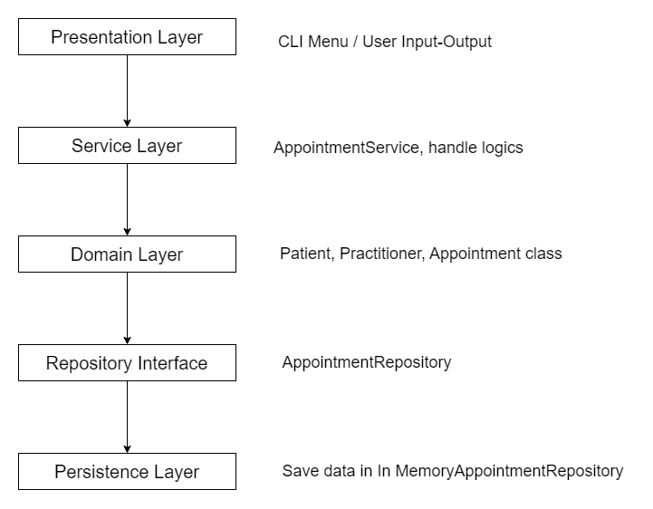

C - Create Package Structure
Create domain/, services/, repositories/, persistence/ and presentation/ or a justified equivalent.
Ans:
smartcare/
├── domain/
│ ├── patient.py
│ ├── practitioner.py
│ └── appointment.py
├── services/
│ └── appointment_service.py
├── repositories/
│ └── appointment_repository.py
├── persistence/
│ └── memory_appointment_repository.py
└── presentation/
└── cli_ui.py

D - Introduce AppointmentService
Move workflow coordination into a focused service without stealing Appointment domain behaviour.
Ans:
Workflow Coordination: The ‘AppointmentService’ was created to handle use-case logic (such as checking practitioner availability and coordinating bookings) without stealing encapsulated domain behavior (like status updates or validations) from the Appointment class itself.
class AppointmentService:
def __init__(self, appointment_repo):
self.appointment_repo = appointment_repo

def schedule_appointment(self, appointment_id, patient, practitioner, time_slot):
# Check availability/conflicts via repository
existing = self.appointment_repo.find_by_practitioner_and_time(practitioner.practitioner_id, time_slot)
if existing:
raise ValueError(f"Conflict: Practitioner {practitioner.name} is already booked at {time_slot}.")

new_appointment = Appointment(appointment_id, patient, practitioner, time_slot)
self.appointment_repo.save(new_appointment)
return new_appointment

E - Repository Abstraction
Define a small AppointmentRepository contract using only current use-case needs.
Ans:
AppointmentRepository Contract: Defined a clean, minimal interface covering only current use-case requirements:
from abc import ABC, abstractmethod

class AppointmentRepository(ABC):
@abstractmethod
def save(self, appointment) -> None:
pass

@abstractmethod
def find_by_practitioner_and_time(self, practitioner_id: str, time_slot: str):
pass

@abstractmethod
def get_all(self):
pass

F - AI Architecture Review
Ask AI to review dependency direction, misplaced responsibilities and unnecessary complexity; request simplest justified improvements.
Ans:
AI Prompt Used: "Act as a software architecture reviewer. Review this small SmartCare Python system against separation of concerns, cohesion, coupling and introductory SOLID principles. Identify concrete layer violations and dependency risks. Prefer the simplest refactoring that solves an observed problem. Do not introduce frameworks, microservices or patterns unless current requirements justify them."
AI Feedback Summary: The AI confirmed that dependency direction was clean after introducing the repository abstraction, but warned against premature optimization, advising against adding full ORMs or SQL databases given the small scope of a community clinic prototype.

G - Refactor and Verify
Apply only justified changes and confirm required behaviour remains unchanged.
Ans:
Refactoring Applied: Separated the CLI menu loop into presentation/cli_ui.py, isolated data storage into persistence/memory_appointment_repository.py, and routed operations through AppointmentService.
Verification: Re-ran all manual test behaviors (normal booking, blank values, duplicate practitioner time slots, and cancellations) to confirm that the required functionality and error handling remain unchanged.

H - Reflection
Document one AI suggestion accepted, one modified and one rejected/deferred.
Ans:
Accepted Suggestion: Accepted the AI's recommendation to strictly enforce dependency inversion through a simple abstract base class (ABC) for the repository interface, which cleanly decouples business services from storage details.
Modified Suggestion: Modified the AI's suggestion regarding exception management; instead of custom exception hierarchies across multiple layers, standard descriptive ValueError exceptions were retained for simplicity.
Rejected / Deferred Suggestion: Rejected the AI's suggestion to introduce dependency injection containers or external configuration files, as they introduce unnecessary complexity for a manageable community clinic prototype.

Suggested AI prompt
Act as a software architecture reviewer. Review this small SmartCare Python system against separation of concerns, cohesion, coupling and introductory SOLID principles. Identify concrete layer violations and dependency risks. Prefer the simplest refactoring that solves an observed problem. Do not introduce frameworks, micro-services or patterns unless current requirements justify them.

